Contents
Section 1. Integration Lab Prerequisites 3
1.1. Launch and Bootstrap your Digital Property Business Network 3
Section 2. LoopBack App Install, Composer integration and Discovery 4
2.1. Create LoopBack application 4
2.2. Configure LoopBack Application for Composer 6
2.3. Launch the Sample LoopBack Application 8
2.4. Discover LoopBack application REST APIs 9
Appendix D. Trademarks and copyrights 14

Overview
The purpose of this lab is to show the integration of external applications (eg, to the HyperLedger Fabric using the Composer LoopBack connector.

LoopBack is an open source Node.js framework composed of many modules that you can use to build REST APIs. The LoopBack model API can be integrated directly into a Node.js application or it can be extended to provide REST web services to be consumed by a REST based client. Additional information on LoopBack can be found at https://loopback.io/doc/index.html

LoopBack bundles their model API through a connector. A connector uses a concept called data sources to represent a connection to an external database or service. Composer provides a LoopBack connector module which will dynamically discover and map a business network domain model, ie. assets, participants, and transactions, to the LoopBack model API. Additionally, REST APIs of the model are also exposed to enable basic create, retrieve, update, and delete (CRUD) functionality for the domain model. Lastly, to easily visualize and interact with the REST APIs a Swagger definition is dynamically generated allowing end users to work with the REST APIs via a browser. Additional information on Swagger can be found at http://swagger.io

Integration Lab Prerequisites

Launch and Bootstrap your Digital Property Business Network
Before we use the loopback app to leverage the LoopBack connector (later on) we should already::

- Have installed our Composer Dev environment and started up a v1.0 Hyperledger Fabric environment-> https://hyperledger.github.io/composer/installing/development-tools.html
- Deployed the sample Digital property network and installed the Digital Property application (to bootstrap some land titles for browsing later). You can get these from GitHub at https://github.com/hyperledger/composer-sample-applications. https://github.com/hyperledger/composer-sample-networks.

For Sample Network:

Enter these commands :

git clone https://github.com/hyperledger/composer-sample-networks.git
cd sample-networks/packages/digitalproperty-network
npm install
composer network deploy -a dist/digitalproperty-network.bna -p hlv1 -I PeerAdmin -s adminpw

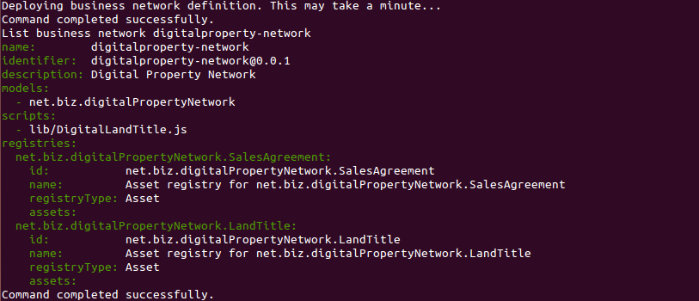

For Sample Applications:

Enter these commands:

git clone https://github.com/hyperledger/composer-sample-applications.git
cd sample-applications/packages/digitalproperty-network
npm install
npm test

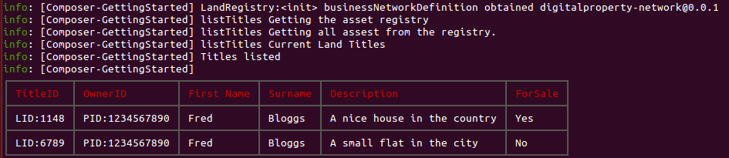

LoopBack App Install, Composer integration and Discovery
In this section, you will install the Composer LoopBack connector,integrate with Composer and interact with the model using the REST APIs displayed via a Swagger document.

Create LoopBack application

Our first set of steps is to generate a skeleton application using the command line interface and configure it to communicate with our Digital Property business network.

  - Open a terminal and change directory to your base directory, ‘cd ~’, if you are not already there.
  - Install strongloop -> npm install -g strongloop

  - Install loopback adapter -> npm install -g loopback

  - To confirm the installation of the framework type ‘npm list -g loopback’.

  - Next, in yout home directory - type ‘slc loopback’ to launch the command line interface to generate a skeleton LoopBack application.

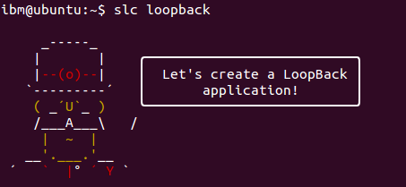

  - A series of questions will need to answered to complete the generation of the application.

my-loopback-app

Take the default directory, which is application name, select Enter. This will create a directory with the name ‘my-loopback-app’ in whatever directory you are issuing the command.

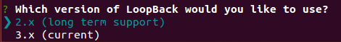
Take the default ‘2.x (long term support)’, select Enter.

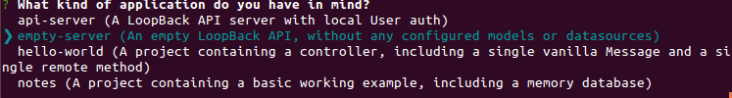

Use the arrow keys to move down and select ‘empty-server’, select Enter.

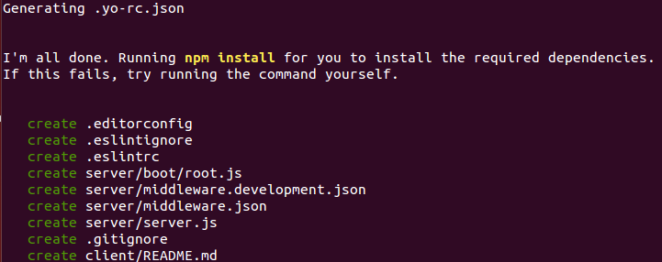

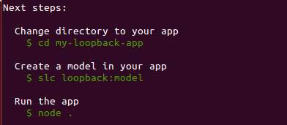

  - The skeleton LoopBack application has been successfully created.

Configure LoopBack Application for Composer

Typically, the next step in building your LoopBack application would be to use the LoopBack command line interface to manually build your model files. In this section, we will leverage a JavaScript file inside the generated composer-loopback-server application which will dynamically connect to (in this example) the Digital Property business network (out under https://github.com/hyperledger/composer-sample-networks) and generate the models in memory. The following steps outline configuring the application.
  - From the Ubuntu Desktop launch the ‘Files’ manager, 

  - Select ‘Home → Workshop → labs → integration’ folder and open the ‘composer.js’ file in an editor to look at the contents.

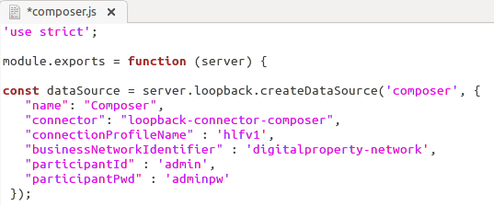

At the top of the file you will see several fields that establish a data source.

name – name of the datasource
connector – NPM LoopBack connector module ‘loopback-connector-composer’
connectionProfileName – Composer connection profile used to determine what physical business network the LoopBack application will be connecting to. The defaultProfile can be found in the ‘home/<user>/.composer-connection-profiles’ directory.
businessNetworkIdentifier – business network namespace established in the CTO file
participantId – ID being used to connect to the business network
participantPwd – password associated with participant ID

In this lab we are using the ‘hlfv1’ in the ‘connectionProfileName’ field as that is currently pointing to our local Digitial Property businesse network. The connection profile name can be modified to use any connection profile.

  - In the Files manager copy the ‘composer.js’ file

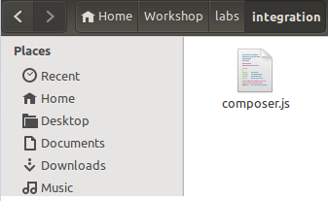

  - From the Files manager navigate to ‘Home → my-loopback-app → server → boot’ and paste the composer.js file into that folder.

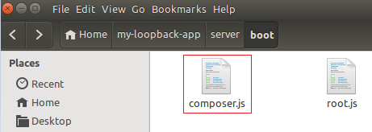

  - In a new terminal change directory, ‘cd my-loopback-app/node_modules’

  - Run the following command to install the necessary node modules, ‘

npm install loopback-connector-composer’

  - To confirm you have the latest Composer modules (v.8) - issue command ‘npm list composer*’ and note I’ve used the ‘*’ at the end..

‘
You have successfully configured the LoopBack application server to work with the Digital Property business network.

Launch the Sample LoopBack Application

Now that we have the LoopBack application successfully created and configured to use our local Digital Property business network we need to launch the LoopBack application. The following steps outline how to launch the application.

- In a terminal change type ‘cd’ to return to the user’s directory

- Change directory to composer-loopback-server directory: ‘

cd my-loopback-app

- To start the application type ‘node .’ (with trailing dot). You should see the following set of messages back to the terminal.

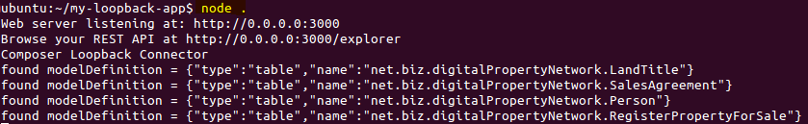

- In the message above you see that a web server is now listening at http://0.0.0.0:3000 and the REST APIs for the Digital Property business network can be viewed in your browser at http://0.0.0.0:3000/explorer. In your Firefox browser open the second link and you should see a page similar to the one below. Go ahead and browse some of the bootstrapped assets.

You have successfully started the LoopBack application that is integrated to Composer.

Discover LoopBack application REST APIs

The final steps in this section will have you use the REST API through the generated Swagger document in your browser to create a new Person, create a new LandTitle, and submit a transaction on that LandTitle.

  - From your Firefox browser return to URL http://0.0.0.0:3000/explorer and click on the Person participant section of the document to view the available REST APIs.

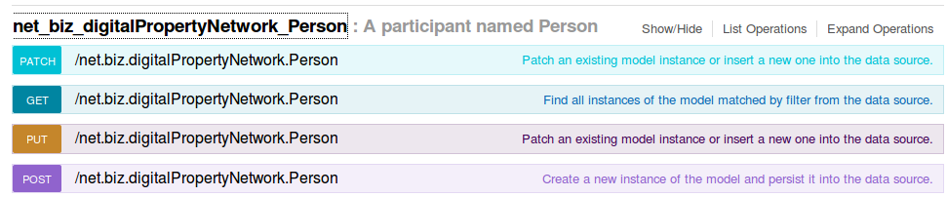

  - To create a new Person we want to use the POST operation. Click on the POST section shown below.

  - With the POST section expanded you will see a number of sub-sections that are avaiable for this operation. The Swagger UI provides a model for this operation and it’s associated fields, type, and relationship to other models. Under ‘Parameters’ click on the model schema example to populate a skeleton JSON structure in the value field.

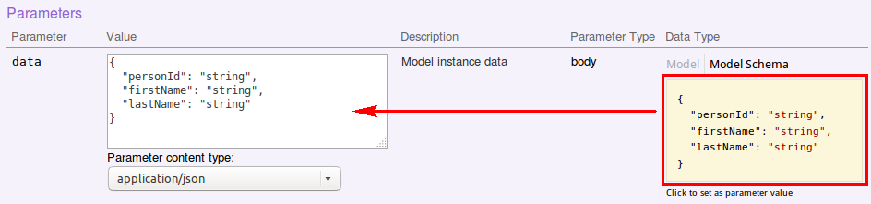

  - In the ‘data’ panel we are provided a new personId, first name, and last name. Update the value field with the following information:

{
"personId": "PID:3333344444",
"firstName": "Bob",
"lastName": "Johnson"
}

  - Once you have updated the value field click on the ‘Try it out!’ button to add this Person participant to the business network.

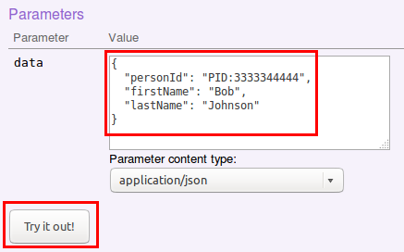

  - To confirm that the REST call was successful scroll down to the ‘Response Content’ sub-section and you should see a response of 200.

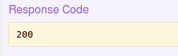

  - Another way to confirm this entry would be to use the GET operation provided for the Person participate. Scroll up and expand the GET operation and click on the ‘Try it out!’ button to get a list of all the Person participates now in the business network.

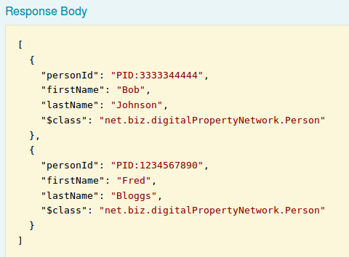

  - Now lets repeat those same steps for a new LandTitle asset using the equivalent POST operation. Scroll up and click on the LandTitle asset. For the LandTitle assets we will need to provide the necessary LandTitle data, which also include the associated owner, which is the Person participant we just created. Click on the POST section shown below.

  - In the ‘data’ panel we are provided a new title ID for the LandTitle asset, an existing owner in Bob Johnson by using identifier ‘PID:3333344444’, information about the asset, and that the asset is currently not for sale. Update the value field with the following information:

    - {
    - "titleId": "LID:4321",
    - "owner": "PID:3333344444",
    - "information": "A house on the beach",
    - "forSale": false
    - }

  - Once you have updated the value field click on the ‘Try it out!’ button to add this LandTitle asset to the business network.

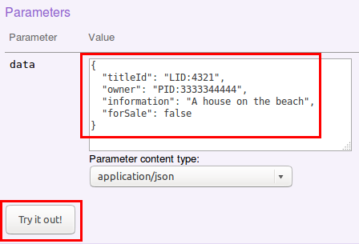

  - To confirm that the REST call was successful scroll down to the ‘Response Content’ sub-section and you should see a response of 200.

  - Confirm the asset has been added by opening a terminal and change directory to ‘cd /home/user/Workshop/clones/github/sample-applications/packages/getting-started/’

  - Enter the ‘npm run listAssets’ helper command to see all the LandTitle assets within the business network. You should see something like the following.

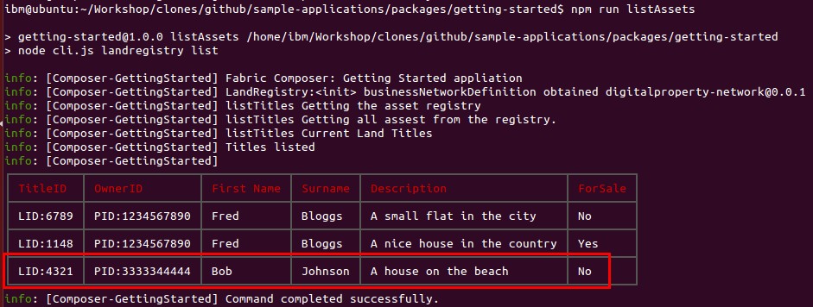

  - Finally we will submit a transaction to show the new LandTitle asset is for sale. Return to the browser and expand the transaction operation ‘RegisterPropertyForSale’. You should see something like the following.

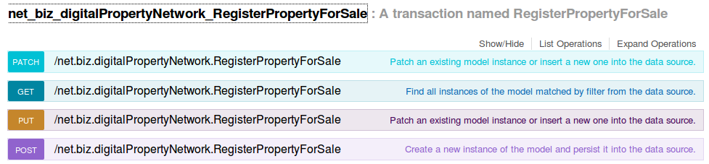

  - Now we will repeat the same steps using the POST operation we did earlier. This time we will provide a self defined transaction ID, a seller identifier of an existing Person participant, a title identifier of an existing LandTitle asset, and a self defined timestamp string value of which we will use a YYYY-MM-DD format. Click on the POST section shown below.

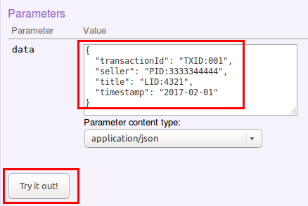

  - To confirm that the REST call was successful scroll down to the ‘Response Content’ sub-section and you should see a response of 200.

  - Return to the terminal and change directory to ‘cd /home/userWorkshop/clones/github/sample-applications/packages/getting-started/’

  - Rerun the ‘npm run listAssets’ helper command to confirm your transaction has updated the asset within the business network. You should see something like the following.

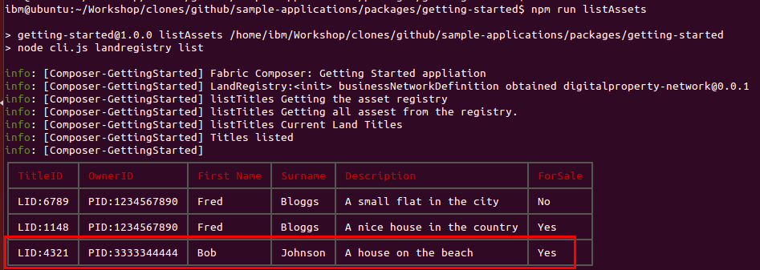

Appendix D. Trademarks and copyrights
The following terms are trademarks of International Business Machines Corporation in the United States, other countries, or both:
IBM | AIX | CICS | ClearCase | ClearQuest | Cloudscape
Cube Views | DB2 | developerWorks | DRDA | IMS | IMS/ESA
Informix | Lotus | Lotus Workflow | MQSeries | OmniFind
Rational | Redbooks | Red Brick | RequisitePro | System i
System z | Tivoli | WebSphere | Workplace | System p
Adobe, the Adobe logo, PostScript, and the PostScript logo are either registered trademarks or trademarks of Adobe Systems Incorporated in the United States, and/or other countries.
IT Infrastructure Library is a registered trademark of the Central Computer and Telecommunications Agency which is now part of the Office of Government Commerce.
Intel, Intel logo, Intel Inside, Intel Inside logo, Intel Centrino, Intel Centrino logo, Celeron, Intel Xeon, Intel SpeedStep, Itanium, and Pentium are trademarks or registered trademarks of Intel Corporation or its subsidiaries in the United States and other countries.
Linux is a registered trademark of Linus Torvalds in the United States, other countries, or both.
Microsoft, Windows, Windows NT, and the Windows logo are trademarks of Microsoft Corporation in the United States, other countries, or both.
ITIL is a registered trademark, and a registered community trademark of The Minister for the Cabinet Office, and is registered in the U.S. Patent and Trademark Office.
UNIX is a registered trademark of The Open Group in the United States and other countries.
Java and all Java-based trademarks and logos are trademarks or registered trademarks of Oracle and/or its affiliates.
Cell Broadband Engine is a trademark of Sony Computer Entertainment, Inc. in the United States, other countries, or both and is used under license therefrom.
Linear Tape-Open, LTO, the LTO Logo, Ultrium, and the Ultrium logo are trademarks of HP, IBM Corp. and Quantum in the U.S. and other countries.

